IntelLayer™ Data Sheet
Table of Contents

IntelLayer Product Data Sheet 2
Product Overview 2
Key Capabilities 3
Business Outcomes 5
Ideal Use Cases 6
Technology Ecosystem Integration 6
Deployment & Engagement Model 7
Why Xperity 7
IntelLayer at a Glance 8

IntelLayer™ Product Data Sheet
AI-Powered Delivery Intelligence for Modern Software Engineering

Transform fragmented SDLC signals into structured engineering intelligence.
Xperity’s IntelLayer helps engineering organizations improve delivery predictability, reduce rework, preserve institutional knowledge, and accelerate safe AI adoption across the software development lifecycle (SDLC).

Product Overview
Modern engineering teams are overwhelmed by fragmented context spread across Jira, GitHub, Confluence, CI/CD systems, architecture documents, runtime telemetry, and team communications. As systems evolve, requirements intent, architecture decisions, dependencies, and operational knowledge become disconnected, leading to slower delivery, hidden risk, and repeated context reconstruction.

IntelLayer acts as a persistent, system-aware Delivery Intelligence Layer across the SDLC. It continuously captures and synthesizes engineering signals into structured intelligence that improves software delivery visibility, governance, and execution.

Rather than replacing existing engineering tools, IntelLayer integrates with the current ecosystem to create a living system model that enables teams to:

- Understand change impact before implementation
- Surface hidden dependencies and delivery risk
- Generate structured engineering artifacts automatically
- Improve alignment across engineering, product, leadership, and operations
- Ground AI workflows in real system understanding and governance

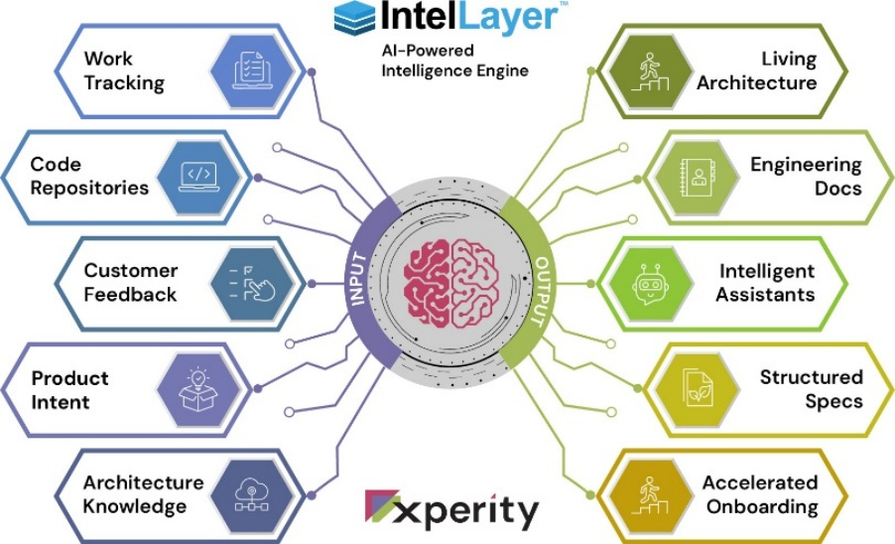

Key Capabilities
Delivery Intelligence Layer
IntelLayer continuously captures and organizes signals across the SDLC, including:

- Code repositories
- Work tracking systems
- Architecture artifacts
- CI/CD pipelines
- Runtime signals
- Team collaboration systems

These fragmented inputs are transformed into structured engineering intelligence, including:

- Requirements and specifications
- Acceptance criteria
- Architecture documentation
- Dependency mapping
- Operational knowledge
- Risk insights
- Delivery forecasting

AI-Accelerated Engineering Workflows
IntelLayer automates the translation of product intent into engineering-ready artifacts.
Instead of manually converting ideas into requirements, user stories, architecture outlines, and testing plans, teams can use IntelLayer to generate structured delivery assets grounded in actual system context.

Example Workflows

- Change impact analysis
- Requirements generation
- Delivery risk modeling
- Dependency tracing
- Release intelligence
- Architecture reasoning
- Operational visibility

Ask Insight™ Interface
Insight is the conversational interface to IntelLayer’s system intelligence. Teams can ask questions across the connected engineering ecosystem and receive system-grounded answers in real time.

Example Queries

- “What happens if we change this feature?”
- “Are we on track for this release?”
- “What changed in the last deployment?”
- “Which services are impacted?”
- “What delivery risks exist?”

IntelLayer converts these responses into structured, shareable engineering reports and operational insights.

Enterprise Governance & Safe AI Adoption
IntelLayer is designed for enterprise software environments where governance, auditability, and security are critical.

Governance Features
- Human approval checkpoints
- Role-based access controls
- Audit trails for workflows and decisions
- Traceability from intent → design → implementation → outcomes
- Secure integrations across engineering systems
- Private deployment options
- Customer data isolation
- No customer data used to train public AI models

Business Outcomes
Improve Delivery Predictability
IntelLayer helps organizations understand delivery risk earlier by surfacing dependencies, blockers, and execution gaps before they become release issues.

Reduce Rework & Context Loss
Teams spend less time rebuilding understanding across releases, systems, and departments.

Accelerate Engineering Velocity
AI-assisted workflow generation reduces manual effort required for requirements creation, documentation, and coordination.

Preserve Institutional Knowledge
Critical architecture decisions, operational history, and implementation reasoning become persistent organizational intelligence instead of fragmented tribal knowledge.

Align Cross-Functional Teams
Engineering, product, leadership, technical sales, operations, and support operate from the same system understanding.

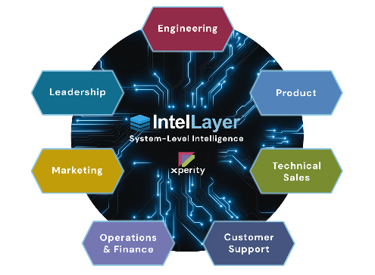

Ideal Use Cases
IntelLayer is especially valuable for organizations with:

- Complex multi-system software platforms
- Distributed engineering organizations
- Large-scale media and broadcast workflows
- High-availability production environments
- AI transformation initiatives
- Delivery predictability challenges
- Long onboarding cycles
- Frequent release coordination issues

Common Industry Applications

- Broadcast technology
- OTT & streaming platforms
- AdTech systems
- Media operations
- Enterprise SaaS platforms
- Cloud-native engineering organizations

Technology Ecosystem Integration
IntelLayer integrates into existing engineering environments without requiring migration.

Supported Ecosystems Include
- Jira
- GitHub
- Confluence
- Slack / Teams
- CI/CD pipelines
- Cloud platforms
- AI coding assistants and agents
- Runtime observability systems

Deployment & Engagement Model
IntelLayer is delivered through a services-led implementation model supported by Xperity’s engineering organization.

Pilot Program
A structured 60–120 day engagement designed to demonstrate measurable engineering value through targeted workflow instrumentation.

Typical Pilot Outcomes

- Reduced rework
- Improved requirements quality
- Better release visibility
- Faster onboarding
- Improved delivery forecasting

Why Xperity
Xperity combines:

- 18+ years of enterprise engineering delivery
- 450+ global engineering professionals
- Deep media & broadcast domain expertise
- AI-enabled software delivery frameworks
- Production-grade governance and quality standards

IntelLayer is built from real-world software delivery experience supporting complex enterprise media systems.

IntelLayer at a Glance
Capability | Business Value
Delivery Intelligence Layer | Unified system understanding
AI-Accelerated SDLC Workflows | Faster engineering execution
Change Impact Analysis | Reduced delivery risk
Delivery Forecasting | Improved predictability
Structured Engineering Artifacts | Less manual documentation
Governance & Auditability | Enterprise-safe AI adoption
Cross-System Intelligence | Better organizational alignment
Persistent Engineering Knowledge | Faster onboarding & continuity

Expert-Led. AI-Accelerated. Intelligence-Driven.
Learn more:
xperity.io

